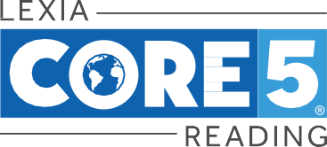

Dear Parent/Guardian,

This year, your child will be using Lexia® Core5® Reading—a fun, computer-based program that has helped millions of students improve their literacy skills. The activities in Core5 support and build on your child’s classroom curriculum and focus on developing reading skills in six areas: phonological awareness, phonics, structural analysis, fluency, vocabulary, and comprehension.

Here’s how Lexia Core5 Reading works:

- Your child begins Core5 at a starting point that fits his or her needs and then engages in online activities throughout the week.
- Online activities include direct instruction and immediate feedback as your child learns new skills.
- Progress and performance in the program are reported directly to teachers so that they can provide assistance when needed.
- Paper-and-pencil activities are also used for practice and may be completed in school or brought home.
- Achievement certificates may be sent home to celebrate success and to show progress in the program.

We hope you share in our excitement about this program! To learn more, visit www.LexiaLearning.com.

Sincerely,

©2019 Lexia Learning, a Rosetta Stone Company. Lexia grants permission to reproduce this letter.
C5-HOMELTR-OVW-0219

